Design Review - Reflection

* Robot at 3rd Qualifier

horizontal line **Date:** Sat, Feb 4, 2016

**Location:** Tigers Qualifier, Greenwich, CT

|  |  |  |  |
| --- | --- | --- | --- |
| **Major Milestones:** |  | **Completion Goal** | **Completed** |
| Mountain Matchup Qualifier - Ridgefield |  | Dec 4, 2016 | Yes |
| Gator Bowl Qualifier - Greenwich |  | Jan 21, 2017 | Yes |
| Determined Tigers Qualifier – West Hartford |  | Feb 4, 2017 | Yes |
| Battle at the Beach – CT State Championship |  | Feb 18, 2017 | Qualified |
| East Super Regional – Scranton, PA |  | Mar 17-19, 2017 |  |
| Worlds Competition |  | Apr 2017 |  |
| Post competition – Hatter’s Scrimmage |  | May 16, 2017 |  |

**Requirements:**

|  |  |  |  |
| --- | --- | --- | --- |
| **Physical Systems –Requirements** | **Required?** | **Status** | **Achieved** |
| Push Beacons | Required | Okay | 3 one touch |
| Side by side beacon pushers | Nice to have | None | None |
| Shoots particles | Required | Okay | Scored 1 Auto |
| Shoots multiple particles (reloads) | Required | None | None |
| Maneuverable – uses Mecanum Wheels | Nice to have | Good | Good |
| Lifts Cap Ball | Required | None | None |
| Places Cap Ball on C.Vortex | Nice to Have | Push w bumper | None |

**Agenda:** Review Robot status at 3rd Qualifier

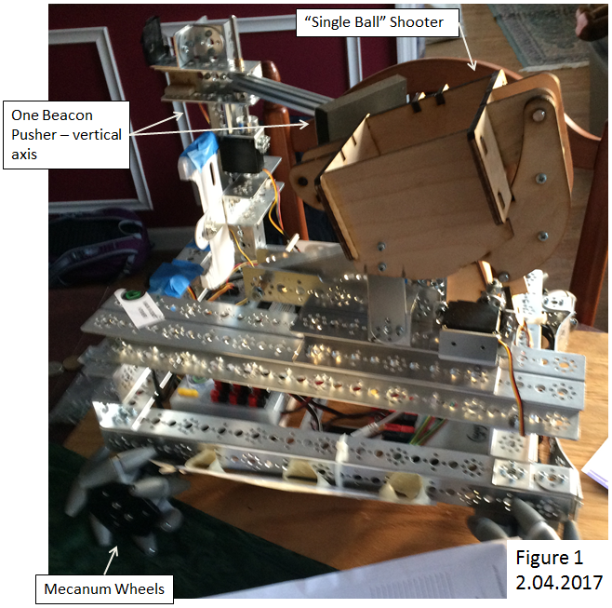

***Updates from 2nd Qualifier:***

* See figure 1.
* Adapted prototype impact particle shooter to robot.

***Observations:***

* Seeded lower third, was not in finals.
* Beacon pusher inconvenient to use – swing out then swing in - slow.
* The wheels worked – maneuverable system, still a light robot. Wheels were washed/cleaned, rotation improved/freer.
* Particle shooter worked – single shot autonomous. Good trajectory, fired reliably, accuracy okay.
* Autonomous continues to be programmed – possible to shoot particle, get cap ball and park in autonomous.
* Pushed a beacon in autonomous – (activated the wrong color).
  + Color sensors not good at detecting beacon color – very limited range. Difficult to determine colors by RGB values, while filtering other colors out.
  + Sensing the line for Autonomous is difficult. Program slow – with sensor delay leading to overshoot – not so important because strafing slowly across line, but too slow to do two beacons at present.

***Suggested concepts for improvement:***

* Redesign beacon pusher – quicker to use, more rugged.
* Continue to develop the particle shooter
* Develop particle re-loader
* Continue to develop autonomous program
  + Look at using the phone vision system for beacon color detection

|  |  |  |
| --- | --- | --- |
| **Action Items** | **Assigned** | **Date/Goal** |
| Robot Design Updates | Engineering | States |
| Autonomous Programming Development | Chandler | States |

|  |  |  |  |
| --- | --- | --- | --- |
| **Prepared By:** | Chandler | **Date:** |  |
| **Overview By:** | G. Edward | **Date:** |  |